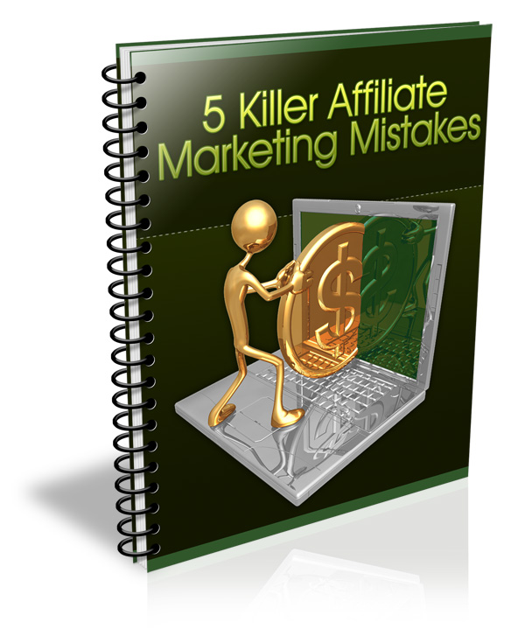
This Report Has Been Brought To You By:
www.YourDomain.com

TABLE OF CONTENTS

INTRODUCTION 3
NOT BUILDING A LIST 3
POOR CHOICE OF AFFILIATE PROGRAMS 5
PUTTING TOO MANY OR TOO FEW ADS 7
PAYING TOO MUCH FOR PPC ADS 8
POOR QUALITY TRAFFIC 10

Download The Complete Guide To Affiliate Profits at: www.YOURDOMAIN.com



INTRODUCTION

Affiliate marketing is a very simple concept. Almost anyone can make money with it very easily. But there are a few things you can do that can derail your efforts big time.
If you know these things before you get started, then you have a much better chance of making really good money right from the start. If you’ve already started your affiliate marketing efforts, you may be making these mistakes already.
But it’s never too late. You can start turning your campaigns around right now, and it only takes a few minor changes in most cases. In fact, just a few easy changes can quickly increase your income. Perhaps doubling, tripling, or even more the amount you make!

NOT BUILDING A LIST
Perhaps the biggest mistake affiliate marketers make is not building an email list. Building a list is crucial in most markets. You need a list of people you can market to again and again.
Unless your sites are particularly sticky (meaning people stay for a long time and come back often), you only get one shot at making money from each visitor.
If someone leaves your site without buying anything, that is a customer lost. They probably won’t be back to your site, so you’ve lost them forever.
But if you get them to opt-in to your email list before they leave, then you have the potential to market to them again and again. You will be able to send marketing messages out to them often, and you may get several sales from a single individual over the course of their membership to your list.
If you aren’t already building an email list, I highly recommend doing so. While not every niche is entirely appropriate for building a list, the vast majority of niches will work very well with email marketing.
You may want to give away a freebie as an incentive to get people to join your list. This might be a free report, or some sort of course that teaches them how to do something. This will help entice more people to join your mailing list.

POOR CHOICE OF AFFILIATE PROGRAMS

When you choose an affiliate product to promote, you should be sure to choose one that you believe will convert well. You should also be sure the company itself is known for integrity, or at least doesn’t have a poor reputation.
It can be difficult to anticipate how well a particular merchant will convert. If you have the opportunity to choose between a number of different merchants for a single product, it won’t always be price that determines how well each one will convert.
There are many factors that determine whether someone will buy from a particular merchant. These factors may include, but are not limited to:
- Whether they have heard of or trust the merchant.
- The price of the item.
- The price of shipping.
- Shipping methods available.
- Reviews of the product or merchant.
- Customer service quality.
- Site quality and usability.
- Quality of the description and sales method.
- Payment methods available.
- Quality and quantity of item photos.
- Many other factors.
Sometimes you may think you have a winning combination. You might find a merchant that has a very low price, low shipping, a great looking site, and a quality presentation, but it may not convert well. There may be factors you’ve missed, or factors you never would have thought of.
In this case, you should test other merchants. It might be that the particular item you’re promoting just doesn’t sell well. It happens! But it may also be the merchant, so you might want to test various merchants before you abandon a product completely.
You also need to look at other products. Sometimes a product just doesn’t convert well at any merchant, in which case you would just need to choose something else.
Occasionally you may choose an entire niche that is unprofitable. This doesn’t happen all that often, but it can happen. In this case, it’s best to sell the site for whatever you can get for it and move on to a more profitable niche.

PUTTING TOO MANY OR TOO FEW ADS

Whenever you make an affiliate site, it may be tempting to put a ton of ads, assuming that the more ads you put on the site, the more clicks you will get.
This is a mistake. When you put too many ads, it will be harder to get links to the site, and people will also be more likely to hit the back button without viewing your site at all.
Think about it for a moment. When you visit a website that has a large number of ads, what is your first inclination? For most people, they assume that the site was made solely for the purpose of making money. They will usually leave if there are too many ads.
Some people make the opposite mistake. They don’t want to “bother” their visitors, so they put very few ads. They may make the ads so small that they are practically invisible. In this case, they will get very few clicks, thus making very little money.
You have to find a good balance. You need to make sure you have enough ads, and they are prominent enough to get clicked often, but not so intrusive that visitors leave immediately.
I like to use Google AdSense’s guidelines. They allow a maximum of three ad blocks per page, and I find that works well for affiliate banners, too.
I usually put one ad at the top of the page, another either in line with the content or in the sidebar, and another at the bottom. On some sites, I may also place a few text links in the content itself.
You should also make sure to showcase the ads in a way that makes them appear to be part of the site, but so they will also stand out. If you make them too obvious, the site will look ugly and spammy. If you blend them too well, they won’t be noticed.
You should test and track various ad types, sizes, and placements until you find a combination that gets you plenty of clicks, but also plenty of sales on those clicks.

PAYING TOO MUCH FOR PPC ADS

Many affiliate marketers use pay-per-click traffic from sites like Google AdWords to send traffic to their affiliate links. It’s a great idea if you have the money to spend, but it’s not easy.
PPC is actually pretty difficult to use if you don’t know what you’re doing. There are dozens of different ways to screw up a PPC campaign, and if you’re not careful, you could end up spending far more than you make.
Another worry with PPC traffic is the fact that your affiliate checks will take a while to come. You may not get paid before your PPC account comes due. If this happens, you’re on the line personally for the bill. If you can’t pay it, you could lose your account!
There are several ways to make sure you pay as little as possible for your clicks:
- Choose long-tail keywords that are very closely related to the product you’re promoting.
- Bid for product names rather than just keywords.
- Be careful to avoid unprofitable keywords like “free”.
- Group keywords into related groups.
- Make sure your landing page is very high quality.
- Make sure your landing page is easy to navigate.
- Don’t send traffic directly to affiliate links.
- Try to get visitors to opt-in to an email list before you send them to your affiliate link so you can market to them over and over.
- Watch campaigns closely and weed out unprofitable keywords.
- Monitor sales and eliminate products that don’t convert.
- Make sure your ads get a high CTR on AdWords. The higher your click-through ratio, the cheaper your clicks will be.
You have to be sure that everything you do on PPC is tracked and monitored carefully. Since you are spending money for every click, you must make sure those clicks are as profitable as possible.
If you can set up named campaigns or use tracking codes in the affiliate programs, you should do so. This will help you see exactly how much traffic you’ve sent via PPC (as opposed to other traffic sources) so you can test various ads and keywords.

POOR QUALITY TRAFFIC

Sometimes you may try a bit TOO hard to get traffic to your sites. You might end up focusing too much on getting a large quantity of visitors, and the quality of the traffic might be too low or untargeted.
While it’s great to have a large number of visitors to your site, it’s much more important to make sure the traffic is quality traffic. By quality traffic, I mean traffic that shares a few traits.
Traffic should be:
- Targeted to the niche.
- More than curious, but directly interested in the topic.
- Willing to purchase something in the niche.
- Able to purchase something in the niche.
The traffic should be well-targeted to the niche of your site. You might be able to get a few thousand visitors from social bookmarking sites to your website about marine aquariums, but these visitors may be only vaguely interested.
You might buy 10,000 random visitors to your marine aquarium site for $9 on eBay, but chances are most of those visitors will NOT be interested in aquarium fish!
But if you got that traffic from targeted keywords via PPC, or if you got the traffic from search engines or a banner ad on a related site, those visitors would almost certainly be interested in aquariums!
Targeted traffic can be elusive. Sometimes it’s pretty difficult to get targeted traffic to your site. If you’re in an extremely competitive niche, you will probably find it fairly hard to get a nice quantity of visitors.
Most of the time it’s just a matter of:
- Getting backlinks from quality, RELATED sites.
- Writing articles on the topic.
- Submitting your site to related directories.
- Buying links on related sites.
- Spending time working on SEO.
- Targeting long-tail keywords with little competition.
- Focusing more on quality than quantity.
Search engine traffic is some of the most targeted and high-quality traffic possible. You should aim for getting at least 50% of your traffic from search engines, if possible.
Why is search engine traffic so targeted?
Well, because people who are searching for something are obviously interested in the topic.
Let’s say you are at a social bookmarking site and you see an interesting article about a recent archaeological find. Out of curiosity, you click the link and read the story. It’s an interesting story, but only because it was a little strange and unusual.
On this site, they are advertising a series of books and videos about ancient civilization. Would you buy? You might. But chances are you wouldn’t. That single interesting story probably would NOT be enough to get you to buy this product, unless you just happened to be interested in the topic already.
Now, let’s say you were extremely interested in ancient civilizations. You get on Google and you search for “ancient civilization” + “recent discoveries”. You find this interesting article, and you read it.
Now you see the ad for the book and video series. Would you buy? If you didn’t already have it and you could afford it, there is a very good chance that you would, because you’re already highly interested in the subject!
This is the kind of traffic you need to get. You need to get traffic that is already interested in a topic. While getting some extra traffic is nice, you should try to focus more on TARGETED traffic.

Start Making Money In Affiliate Marketing Today!
If you want to learn more about making money with affiliate marketing, I have a fantastic guide available to teach you step-by-step how to make money.
You can make money:
- Even if you have never made a website.
- Even if you have no money to invest.
- Even if you only have a couple of hours per week.

Visit www.YOURDOMAIN.com To
Download The Complete Guide!

